Disclosing Cultural Diplomacy Practice in the Digital Age
By Assigning Korean Celebrities as Brand Ambassadors for Indonesian Products

Fatma Dian Pratiwi ^{1*}, Maya Sandra Rosita Dewi², Rahmah Attaymini³ , Rama Kertamukti⁴
¹ ² ³ ⁴ Communication Studies Program, UIN Sunan Kalijaga, Yogyakarta, 55281
*fatma.pratiwi@uin-suka.ac.id

Abstract
This article reveals how digital culture diplomacy practice manifests in the assigning of Korean celebrities in Indonesian products’ brand. This is related with the Indonesian people’s interest into Korean culture. Following the entry of the Korean wave of culture into Indonesia, especially through digital media such as social media, drama, fashion, music, and tourism. Since cultural diplomacy is not only limited to cultural exchanges sponsored by the Government or the State and carried out directly. In the digital era, cultural diplomacy is carried out by digital media and can be carried out by non-government actor use as brand ambassador for products such as foods, beauty products, fashion and so forth. This research uses a qualitative approach with the Case Study method. While the analysis is carried out using the VisCap model analysis which includes Visibility, Credibility, Attractiveness, and Power. These four aspects are then analyzing within the framework of cultural diplomacy in the digital era. The results of this study explain that the current culture of diplomacy is carried out in a way called soft powers. One of them is by how Indonesia uses Korean celebrities as brand ambassadors for their local brand. The reason for choosing is due to the celebrity's popularity, credibility, attractiveness, and power, which also boosts the products offered and establish attention. The relations between using Korean celebrities as brand ambassadors is certainly felt by Korea and Indonesia, which previously had been well established in diplomatic relationships.
Keywords: Cultural diplomacy in the digital age, Korean celebrity, Indonesian Product Brand Ambassador

Introduction
Using celebrities appointed as brand ambassadors for several products has become common in Indonesia. In fact, not only in Indonesia but also throughout the world. For example, many countries in Africa and Asia including Nigeria were previously unaware by the concept of using celebrities to endorse various brands (Zafar & Rafique, 2012). Hence, in recent years there has been a strengthening of the global market as more businesses compete for the same market audience. The use of celebrities to attract the attention and business of their audience is one of the many marketing communication tactics that businesses use today in an effort to snatch market share from their competitors (Nelsom, Okorie. Deborah, 2017). However, in the current phenomenon we discover that many product brands in Indonesia choose Korean instead of Indonesian celebrities as their ambassadors. For some names, such as Choi Siwon, a member of the boy band Super Junior who is the Brand Ambassador for Mie Sedap brand products. Lee Min Ho, a top Korean drama actor who becomes the brand ambassador for the Roma Kelapa biscuit product and Cha Eun Woo who becomes the Brand Ambassador for beauty product brand MS Glow. In addition to these foods and beauty product, the investment and banking products for Indonesia SIM Investment also use V who is a member of the Korean Idol group, BTS (Bangtan Seonyondan) as a Brand Ambassador. Also, Lisa from a girl band called Black Pink as a Brand Ambassador for the Magic Investment brand (Ajaib).
The manufacturers' decision to choose them as Brand Ambassadors must be made with certain considerations. In this case, it is hoped that the big names of Korean celebrities among fans of Korean cultural products will attract interest in making purchases and investments. Apart from that, indeed, it also attracts non-K-Pop fans since the increasing of global influence on the spread of this culture, one of which is due to the social media using (Siagian et al., 2017). As one of the proofs, there was research that has been conducted which analyzed how BTS, a boy band from South Korea, become an important factor for consumers to make brand switching or changes in brand selection in Indonesia, from Shopee to Tokopedia (Hwang- Joanna Elfving, 2023). This phenomenon raises questions. Especially in the context of cultural diplomacy as soft power. This is since, celebrities become part of the artist, only if they are open about their origins, then artists who are internationally successful and able to speak to foreign audiences can contribute to the soft power of the nation or country of origin. When these musicians or Korean idols and actors receive media attention, their influence increases but they do not diminish or even highlight their national identity (Saliu, 2017).
Due to this fact, in recent years, the Korean Wave, also known as Hallyu, has spread impressively all over the world. Starting from East Asia as the country of origin, namely South Korea, to Southeast Asia. It even penetrated into Europe and America (Bok-rae, 2015). The term "Korean Wave" (Hallyu in Korean) refers to a variety of cultural phenomena, including Korean-language television dramas, movies, K-pop music, B-boy dancing, and, to a lesser extent, video games, food, clothing, and other trends (Jang & Paik, 2012). A little over ten years ago, the Chinese press (Hanliu in Chinese) coined the phrase "Korean Wave" to describe the popularity of Korean pop culture in China. This spread started from people who liked K-Drama (Korean Drama), K-Pop (Korean popular music or Boy/Girl Band), film, food, fashion and beauty products in China, Japan, and Vietnam. This phenomenon is so massive that it ultimately contributes to economic growth and also the good image of South Korea around the world (Ganghariya & Kanozia, 2020).
Moreover, the actions of the South Korean government, which continuously support its cultural industry, are inextricably linked to the rise of Hallyu. beginning in 1998 with Kim Dae Jung's presidency and ending in 2003. Assuming the title of "President of Culture," President Kim Dae Jung vowed to dedicate his life to advancing South Korean culture. Its policy is to set laws and regulations that serve as the cultural industry's legal foundation and to set aside US$148.5 million for the sector's growth (Aslam, 2020). It continued under President Lee Myung Bak's administration. The primary strategies employed by Lee Myung Bak's administration to improve public diplomacy, cultural diplomacy, and the nation's image and state branding were "complex diplomacy" and "value diplomacy" (Jang & Paik, 2012). Since then, 5.3 trillion won ($5.2 billion), or around 1.4 percent of public spending, has been allocated by the government to pop culture (Aslam, 2020).
Therefore, these facts are strong evidence of how seriously the South Korean government pays attention to their cultural diplomacy practices. Particularly Indonesia which is no longer a market for the rapidly proliferating Korean Waves, according to Simanjuntak in Fitria (2021). Instead, it has become a component of the phenomenon. Indonesia is an important partner of South Korea, according to Kim Yong-Woon, the head of the Korean Cultural Center in Indonesia. The desire to study Korean, eat Korean food, sing Korean songs, and take in Korean culture is growing among Indonesians (Fitria et al., 2021) . So, it is not surprising that currently South Korean cultural products are widely known in various countries. One of them is Indonesia. For this reason, this article focuses on how South Korean celebrities, including drama/film actors and actresses as well as K-Pop singers, were selected to become Brand Ambassadors for Indonesian products in the context of cultural diplomacy in the digital era.
LITERATURE REVIEWS
- Cultural Diplomacy in the Digital Age
The American researcher F. Barghoorn coined the expression "cultural diplomacy" in the 1930s and spread it throughout the scientific community. He claims that this form of cultural diplomacy “uses cultural resources and personnel for propaganda purposes” (Gumenyuk et al., 2021). While the conceptual framework of "cultural diplomacy" is complicated (Zappavigna & Martin, 2018). Both "high" (literature, arts and education) and "popular" culture are components of culture, which are value systems that produce content that is meaningful to society. This country department aims to show how to conduct cultural diplomacy to foreign audiences. The fundamental pillar of public diplomacy is cultural diplomacy, which takes the form of educating the world community, fostering relationships with other people in the fields of education and culture.
Meanwhile, diplomacy (including culture) can be seen as representation, negotiation, reporting, and protection of citizens abroad which are the four main functions (Stephens & Robertson, 2022). Therefore, in this digital era, analyzing the impact of global digitalization on cultural diplomacy is also very important. The concept of state "soft power" is considered as an instrument for increasing the influence of conditions on world political processes in the twenty-first century, with the weight of military-political and economic resources, the impact of globalization processes, and the circumstances surrounding the creation of a new polycentric system of international relations
Thus, building and fostering cross-border relations in areas such as trade, politics, culture, diplomatic and economic components are the roles and objectives of cultural diplomacy; to communicate with overseas organizations, such as the diaspora, and maintain relationships despite problems. A wide range of parties are involved in resolving the dimensions of cultural diplomacy, including state authorities that mediate and support contacts and exchanges and non-state actors, including various non-governmental organizations. International relations are as exchanges between cultures, claims the Harvard diplomacy historian (Saliu, 2017).
Moreover, we discuss about the strategy execution method consists of at least three stages: 1. The introduction, which is accomplished by exposing K-Pop to the Indonesian populace directly through the community, entrepreneurs, and, occasionally, the opening through simple access to official social media accounts. 2. Policy: The South Korean government has publicly said that it completely supports K-Pop, a component of the Korean Wave, as a tool for cultural diplomacy to advance its national objectives. 3. Cooperation, used as a direct implementation strategy. This is demonstrated by the government and commercial sector working together to conduct a number of K-Pop-related events (Ismail et al., 2023).

b. Korean Celebrities Worship
Even though many consumer research studies operationalized engagement as a single measure, involvement actually has several stages when viewed in the context of psychology (Halim & Kiatkawsin, 2021). According to Maltby, Giles, Barber, and McCutcheon in (Tresna et al., 2021), celebrity worship is characterized as a para social or one-sided connection in which the individual knows about the celebrity but not the other way around. According to its intensity, Maltby categorize celebrity worship into three categories: entertainment-social, intense-personal, and borderline-pathological. The lowest level of celebrity worship relates to a superstar's capacity for entertaining and grabbing the attention of their followers. An intense and compulsive feeling toward celebrities is a part of the intense-personal element. The most extreme kind of celebrity worship, which is evidenced by the readiness to do anything for a beloved star, is almost psychotic.

c. Brand Ambassadors
Understanding Brand Ambassador is a supporter of products marketed in the media, also known as advertising stars. Businesses employ brand ambassadors to persuade or invite customers to take advantage of a product (Timpal et al., 2022). In (Fitrianto et al., 2020), Rossiter and Percy divide the quality of brand ambassadors into the following categories: (1) visibility, the popularity of a public figure chosen as a brand ambassador must be very attached, because it determines how famous they are in the eyes of the general public, ( 2) credibility, which is cultural background, experience, and psychology in the perception of communicators who are influenced by the five senses. (2) attractions; (3) attractiveness; (4) strength; (5) the power to increase purchase intensity because it is appropriate to order customers to display their likenesses and take purchase actions.

Methodology
This research uses qualitative research paradigm with a case study method or approach. Data collected in qualitative research according to (Yin, 2018) are in the form of words, pictures, and not numbers. While using a case study approach since this research focuses intensively on one object being studied as a case. As explained by (Yin, 2018) who said that case study design is a suitable strategy if the research subject is related to How or Why, when the researcher has little opportunity to control the events to be investigated, and when the focus of the research is on contemporary (present) phenomena in real-life contexts.
The analysis used in this study uses the VisCAP model analysis, is characterized by visibility (being widely known), credibility (having the ability to be trusted), attractiveness (fulfilling favorable characteristics), and power (having the ability to convince or persuade the public).. As explained by Rossister and Percy (Kelley et al., 2015; Rossiter & Smidts, 2012) which explains that VisCAP consists of four elements including: Visibility, Credibility, Attractiveness, and Strength. It was further explained that Visibility has a dimension on celebrity popularity, credibility refers to attractiveness that focuses on power, namely the celebrity's ability to convince customers to buy, not just their attractiveness, and celebrity's knowledge of the products being marketed (Kertamukti, 2015). The data collection technique used is adapted to the data collection model in the case study approach.
As explained by (Yin, 2018) which states that data collection in case studies was obtained from six sources, namely documents, archival recordings, interviews, direct observation, participant observation, and physical devices. While the research process goes through the process of defining and designing research, preparing then collecting and analyzing data, after that it is re-analyzed and finally conclusions are drawn (Yin, 2016). This study took the type of data interviews and direct observation. Observations made by researchers by observing advertisements that use Korean artist BA and conducting interviews with consumers exposed to these advertisements.

Results and Discussion
This research reveals how the practice of cultural diplomacy in the digital era is realized through the appointment of Korean celebrities as brand ambassadors for Indonesian products. Indonesians' growing interest in Korean culture through digital media, such as dramas, music, and social media, encourages many Indonesian products to use Korean celebrities as brand ambassadors. Cultural diplomacy is no longer limited to government-sponsored cultural exchanges, but also involves non-state actors through digital media, particularly in promoting food, beauty, fashion and other products. Cultural diplomacy in the digital era occurs massively, especially through social media. Indonesian brands, such as Mie Sedap, MS Glow, and Ajaib, utilize Korean celebrities such as Choi Siwon, Cha Eun Woo, and Lisa Blackpink as their product ambassadors. The selection of these ambassadors is based on the popularity, credibility, attractiveness, and power of these celebrities in influencing the purchasing interest of the Indonesian people. The use of Korean celebrities as ambassadors for Indonesian products is seen as an effective marketing strategy and is also part of soft power cultural diplomacy. The link between the popularity of Korean culture and Indonesian products creates stronger diplomatic relations between the two countries. This cultural diplomacy has a positive impact on the sales of Indonesian products in the local market.
Analysis using the VisCAP model (Visibility, Credibility, Attractiveness, Power) illustrates the effectiveness of Korean celebrities as brand ambassadors in the context of cultural diplomacy. The analysis shows that the popularity of Korean celebrities not only increases product sales, but also strengthens South Korea's diplomatic image in Indonesia. K-Pop fans in Indonesia play a big role in increasing sales of products that use Korean celebrities as brand ambassadors. They feel emotionally attached to the products advertised by their idols, which contributes to the marketing success of these products. with the analysis description shown in several stages. These advertisements include advertisements for Roma Kelapa biscuits starring Lee Min Ho and Choi Siwon as the brand ambassador for delicious noodles originally from Indonesia.
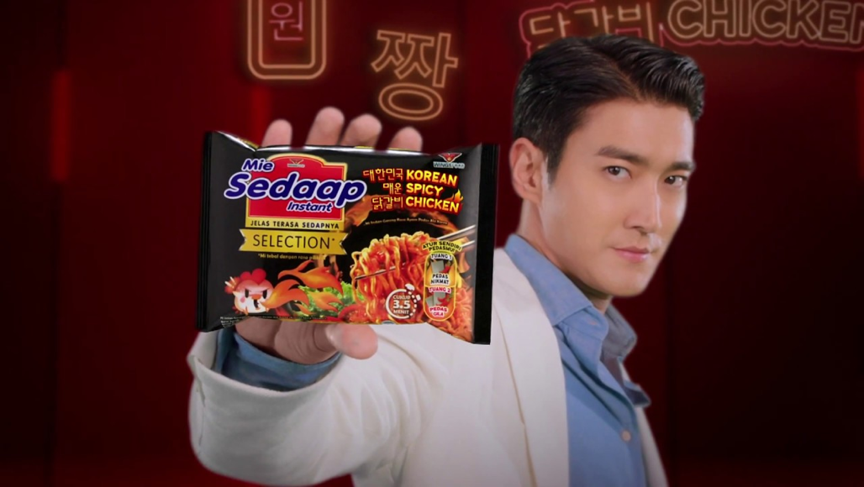
Picture 1 Mie Sedap Korean Spicy Variant with Brand Ambassador Choi Siwon
The use of brand ambassadors from Korean celebrities has proven to influence people's buying interest in Indonesia. As explained by one of the informants in this study with the initials T, aged 23 years, female sex. T (Source from Interview, June 2023) explained that interest in buying delicious noodle products has increased since the advertisement stars used are their idols, and due to the presence of a new menu that is currently popular, namely the Korean-style noodle menu with the Korean spicy chicken variant. This is similarly reinforced by the statements of expert informants as triangulation of sources of opinion.
“...The phenomenon of the widespread use of Korean celebrities for typical Indonesian products is a common thing in the marketing and advertising industry, Korean celebrities have become a separate magnet (apart from being handsome/beautiful) for the public, not only because of their products, this has become commonplace for industry players to use brand ambassadors from other countries…” YD (Expert Interview, July 2023)
On the other hand, informant 2 of this study with the initials F, 21 years old, female explained, "I buy products because of the artist, sometimes if there is a certain product launching a special edition from the K-Pop artist I like, I will definitely buy it. Sometimes they are not used, they are just collected. If you don't eat food, I keep the wrappers for collection” (Interview, June 2023). The presentation of two informants can be explained that using Korean stars coupled with carrying Korean culture is believed to be able to increase sales. Although in fact the product may not necessarily prove to be in accordance with what is advertised, since before using the product the ad star already had good posture and skin.
For example, Indonesian skincare products use Korean artists Song Jong Ki (Scarlet brand ambassador), Cha Eun Wo (MS Glow brand ambassador), and Lee Min Ho (Azzarine brand ambassador). Informant T explained that "I use skincare products to be honest, there is also a little influence from the BA (brand ambassador), I've been using Scarlet since they brought Song Jong Ki to Indonesia... yes, even though I didn't see it directly either. But if we use the products, especially those advertised, it's like we're close to Song Jong Ki” (Interview, June 2023). The statements of the two informants above were reinforced by the presentation of expert sources who stated:
“...The use of Korean celebrities has the goal of attracting consumers' attention and creating an emotional connection with the product or brand. This phenomenon can be an effective strategy for companies to increase the popularity and sales of their products. Users of these products feel close to BA because the products they use are advertised by Korean artists who are their idols, idols in the film world (drakor) and product advertisements are also used…” YD (Expert Source, July 2023)
However, the third informant from this study, who had the initials FA, was 20 years old, male. FA explained:
“...I'm not too affected by the brand ambassador, I'm more into product reviews. It's just undeniable that as a K-Pop fan, I often stalk social media about my favorite stars or movies. This sometimes causes advertisements with Korean stars to also appear on the homepage of social media. Out of curiosity, open the ad and look at the reviews. If you're sure, buy it. And right now, I'm using skincare that uses Korean artist BA, the only basic reason is because the reviews are good and many are using it…” (Interview, June 2023)
The explanation from the third informant explained that the use of the product is not based on the advertisement brand ambassador, but rather on product reviews. However, it cannot be denied that the third informant found the product due to an advertisement for the product was circulating on his social media homepage since the informant likes K-Pop. This is related to the fact that before purchasing decisions are made, Consumers prefer their reviews and ratings to be checked. For the same purpose, there is a small number of other aspects. The results showed on some research that most consumers thought reviews and ratings were very good. Provide enough information about these reviews. Also, the ratings are incredible. Consumers have a tendency to believe reviews, ratings available on the internet (Rawat, 2023). Moreover, they also develop a fondness for the brand. Brand love is "the degree of passionate emotional attachment a satisfied customer has for a particular trade name," according to this includes "feelings of passion and connection toward the brand," as defined by to the point where the loved brand is seen as irreplaceable (Nadila & Windasari, 2022).
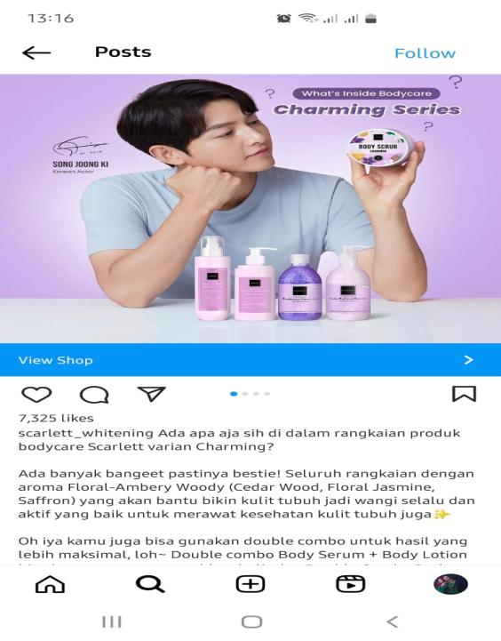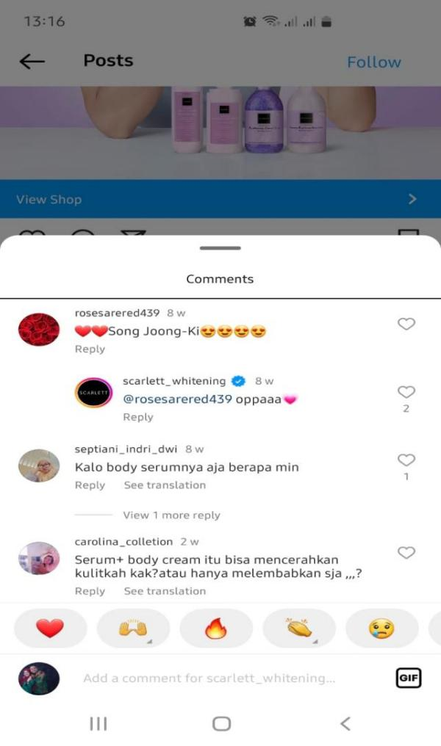
Figure 2 Netizens' Comments on Scarlet Products with BA Song Joong Ki
The spread of K-Pop culture in Indonesia has had an impact on the product sales marketing strategy, which has become a manifestation of the success of Korea's cultural diplomacy. As in South Korea, South Korea's cultural diplomacy is based on the desire to improve the image of the country and gain more recognition at the international level, as in the early 1990s it attracted the international community because it became one of the "Asian miracles", namely the Asian country with the largest economy growing rapidly (Lee et al., 2021). The entry of K-Pop in Indonesia through digital media is said to be soft power or soft diplomacy that is well received by the Indonesian state through its people. The effect of having a culture of subtle diplomacy on social media is as explained by the expert sources:
“...The entry of Korean Pop culture has had a very significant impact and effect on the industry in Indonesia. In fact, our digital page has been flooded with the faces of artists or brand ambassadors from other countries, in this case South Korea, this confirms that their power can enter and be accepted in that country. However, it is also important to pay attention to and respect Indonesian culture and ensure that the use of Korean celebrities does not remove the Indonesian cultural identity from these products. (Expert Speaker, July 2023)
An analysis of the use of brand ambassadors is reviewed through the VisCAP model as a form of cultural diplomacy in the digital era.
The use of Korean artist brand ambassadors for Indonesian brands or products as a medium to influence consumers to buy products. The strategy for using brand ambassadors can be analyzed using the VisCAP model, as described by Percy & Rossiter (Percy & Rossiter, 1983) which consists of Visibility, Credibility, Attraction, Power. The use of Korean artist brand ambassadors for typical Indonesian products is not only an effective marketing strategy to influence consumers, especially K-Pop fans, who are quite a lot in Indonesia. However, as a form of cultural diplomacy between Indonesia and Korea, it is quite well established. The culture of diplomacy is currently rife in digital media. Apart from being more effective, this digital diplomacy culture is a step that is quite soft and even invisible so that it seems as if it is not doing it even though it has been exposed to the diplomatic culture of certain countries. Therefore, this culture of digital diplomacy is included in the criteria of soft power or soft diplomacy.
Visibility (Popularity)
Visibility refers to the popularity of the Brand Ambassador charm. The popularity of the brand ambassador affects the popularity of the product, so a brand ambassador must be someone who has sufficient visibility to be noticed by the public. Visibility refers to the level of awareness of the brand ambassador in society. A brand ambassador who is known to the public and is successful in his field will certainly easily attract the public's attention to optimally carry out his duties as a brand and company representative. For example, in the Roma Kelapa biscuit advertisement, which uses BA, a well-known celebrity in Korea and has quite a lot of fans in Indonesia. As was done by Roma Kelapa Biscuit, which brought Lee Min Ho to become a brand ambassador and was launched during the month of Ramadan in 2023. This strategy was considered successful, because the advertisement for Roma Coconut Biscuits previously did not get much attention. After using Lee Min Ho, the advertisement became widely discussed by Indonesian people, especially fans of this celebrity.
These advertisements are not only trending on television but are also busy in discussions through other digital media such as Instagram, Tiktok, Twitter, and others. Lee Min Ho's popularity made Roma Kelapa Biscuits rise in prestige among women. With the tagline “No.1 Biscuits, No.1 for Mothers,” Roma Kelapa biscuits are suddenly popular among women. Netizens, who are dominated by women, also responded to the Roma Kelapa biscuit advertisement that appeared on their social media homepage. As quoted from the tiktok account @minozann who commented “Mas usually eat biscuits with the family. Let's have a family?" On one of the social media accounts, Twitter is also busy being discussed. for example, in one of the following accounts below.
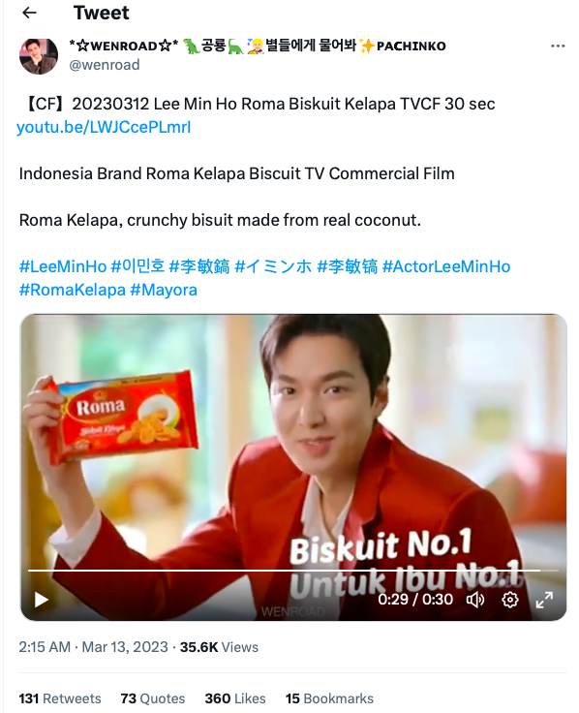
Figure 3 Netizen Responses on Social Media Twitter Roma Coconut Biscuits Ads
Based on the account above illustrates the response to the Roma Kelapa biscuit ad which has become booming since using the Korean celebrity Lee Min Ho, who is quite popular in Indonesia. The popularity of celebrities is also able to boost the popularity of the product. This is in accordance with the presentation of Percy and Rossiter (Percy & Rossiter, 1983) which explained that a brand ambassador who is known to the public and is successful in his field will certainly easily attract the attention of the public to optimally carry out his duties as a brand and company representative.
The popularity of Korean celebrities so that they are made brand ambassadors by business companies in Indonesia, is a form of cultural diplomacy. As stated by Grinceva (Putri & Trisni, 2021) which states that one of the sub-sets of public diplomacy in this case is not only in the form of state-sponsored cultural exchanges but can also be in the form of cultural exchange activities by non-state actors. From this explanation it can be said that in this case the culture of diplomacy is not only limited to cultural exchanges sponsored by each country. However, it is also carried out on actors who are not sponsored by the state. In this digital era, making diplomatic cultural practices easier to do. Because it can be done through digital media which incidentally is very close and easy to reach by the community.
Credibility
Credibility has the meaning as a set of perceptions about the advantages possessed by the source so that it is accepted or followed by the public. This credibility, ability and advantages can attract people to tend to agree, like based on the credibility of the person representing the product, in this case an endorser. An endorser has a very important role since he/she has advantages, good credibility so that be able to play a very big role in every process. The character he has will be able to determine the level of credibility he has. Two factors that play a role in determining the credibility of the endorser, including:
First, Expertise. The character of expertise can show how extensive knowledge the endorser has. Someone who has a high score on this factor will be intelligent, capable, skilled, know a lot, experienced or trained. According to (Bloomfield & Jacobs, 2018) expertise is the perception that the communicant has of the communicator's competence about the subject under discussion. The second characteristic is Trustworthiness, which considers how an advertisement is presented and how a celebrity or endorsement is employed. This refers to how truthfully the endorser's activities, competence, experience, and self-skills are represented in the advertisement that is delivered or advertised.
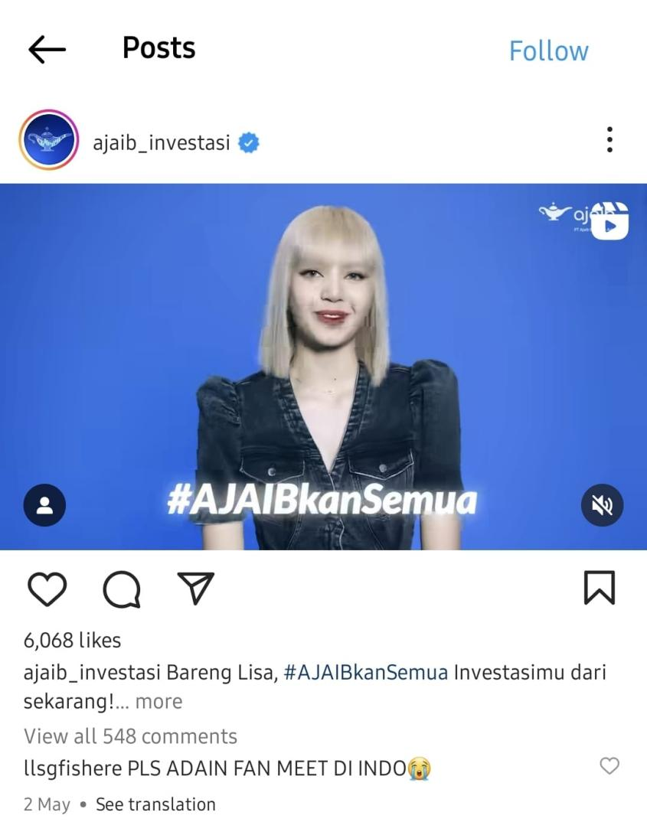
Figure 4 Lalisa Manoban (Black Pink Member) As Brand Ambassador for Magic Invest (Majaib)
From the picture above, we all aware that Lalisa has very good credibility. She is known that she is a member of the Black Pink Vocal Group who already has fans of hundreds of millions of followers, as evidenced by her own personal account which has reached 95 million followers. This is coherent with the statement conveyed by Person F (Interview, June 2023) “...Lisa is a complete package, smart, able to speak many languages, has a good voice, good communication skills, that's why she was lined up to become a BA in an investment company, she is also a BA in class products. like CELINE, we know the price of her products is expensive, she's a classy person…”
The above statement reinforces that a brand ambassador should have high and good credibility, and that is represented by a woman who has good competence and knowledge. Credibility itself involves 2 important things, namely expensive, competence & objectivity that the person has. In terms of competence, it refers to the knowledge, experience, or skills of brand ambassadors regarding the brands or products they represent. A brand ambassador seen by experts is more persuasive in changing the way consumers think. Objectivity has more to do with using brand ambassador abilities objectively to consumers for the brand or product. Brand ambassadors use their abilities in an objective and reliable manner to represent the brand they are promoting.
Indirectly we have been in the practice of cultural diplomacy, as the fundamental pillar of public diplomacy is cultural diplomacy, which takes the form of educating the world community, fostering relations with other people in the fields of education and culture, and promoting perceptions that benefit their own people abroad (Gumenyuk et al., 2021) The use of Korean celebrities or artists as a form of fostering relationships with other people in the fields of education and culture, promoting Indonesian goods or products so that they can benefit the company and the country. Coupled with the use of Brand Ambassadors who are not playing games in the sense of having the ability, knowledge, credibility, popularity, and attractiveness to attract consumers' interest.
Attraction
Attractiveness is a brand ambassador attribute that is considered attractive to arouse consumer interest in the brand or product it represents. In using celebrities, two important things are of concern for attractiveness, first, public or consumer sympathy (similarity) and similarity to the personality or image desired by brand or product users (similarity). When the two cannot be separated and must coexist. Brand ambassadors must reflect well on the brand personality that is built through advertising so that the message the company wants to convey can be done properly. In this case as a Brand Ambassador has a duty to have an appeal that can attract sympathy from the community and the extent to which the image that the company wants to convey to the public.

Figure 5 Cha Eun Woo as Brand Ambassador MS Glow

The attractiveness of a brand ambassador consists of two characteristics. Charm is the attractiveness of physical appearance and personality. Likes are the most relevant for changing attitudes towards the brand. Similarity The target audience must match the emotional image in the advertisement, and this is supplemented by showing someone in the advertisement who has a similar style to members of the target audience. This is reinforced by the statement of informant T (members interview, June 2023) which states that each Brand Ambassador has its own charm:
“...Having a handsome, charming, and attractive face who doesn't know Cha Eun Woo, his cute and handsome face has become the attraction of women, especially since MS Glow partnered with him as a Brand Ambassador, it's crazy how successful this product is after they use it boom Korean artist BA. The attractiveness of the artists they use is also not half-hearted. Eun Wo has a charismatic, cheerful, and dancing charm, young people including me will immediately fall in love, but I only use certain products for her products, because my skin is sensitive…”
Through this research, it supports the statement that Percy and Rossiter's opinion (provides several statements that the selection of the right celebrity will tightly tie the brand of the product to a brand as represented by a celebrity, since celebrities are a real form of various images that consumers think of a brand or brand. The right marketing communication strategy can prevent companies from losses due to ineffective and efficient promotional activities (Dwivedi et al., 2021). Messages conveyed by famous celebrities will receive greater attention and are also very easy to remember. Furthermore,
…Yes, Korean brand ambassadors can enter the realm of diplomatic culture in digital media. In today's digital era, the influence of social media is immense, and many countries use brand ambassadors to promote their culture, tourism, and products to a global audience. Brand Ambassadors have the ability, competence, and attractiveness to the Indonesian people. Korea has used brand ambassadors such as celebrities, artists, and K-pop idols to introduce their cultural heritage, such as food, fashion, music, and films, to the world through digital media. They can cooperate with the Korean government and cultural institutions to extend their cultural influence on other countries…” YD (Expert Source, July 2023)
From this explanation it can be said that in this case the culture of diplomacy is not only limited to cultural exchanges sponsored by each country. Indirectly by using Brand Ambassadors who come from abroad they also introduce the culture that exists in their country to our society through product advertisements that use them as Endorsers, moreover this is very easy to find in the company's digital media (Agam, 2017).
Power
According to Rossiter and Percy (Percy & Rossiter, 1983), Power is the fourth characteristic of strength possessed by Brand Ambassadors. By appearing to command the target to act, power can increase the intensity of purchasing goods without changing attitudes. Brand ambassadors must be able to persuade consumers to use the product. Brand ambassadors who have the power to influence consumer opinion, choose brands, improve brand image in the eyes of consumers, and retain consumers.
One indicator that a celebrity is said to have power is seen from the number of followers on their social media accounts, one of which is Instagram. This fact was conveyed by Koreaboo.com by Jenny Kang as writer, SNS has shown that the popularity of an actress is positively correlated with the number of her followers (koreaboo.com). Regarding this, Lisa Blackpink and V BTS are two idols who currently have the most massive followers on social media namely Instagram. The number of Lisa's Instagram followers with the account name @lalalalisa is 96.1 million followers. While V BTS with the account name @thv, has a total of 60.7 million followers, making V become the male idol who ranks first in terms of the number of Instagram followers. Both are Brand Ambassadors for Indonesian products,
In this regard, one of the strengths of V BTS as the SIM Invest Brand Ambassador was demonstrated in June 2023. At that time, SIM Invest held a fan meeting for SIM Invest consumers with V BTS in South Korea. SIM Invest itself is an online investment application launched by Sinarmas Group Indonesia. The requirement to win this fan meeting opportunity is to divide 2 categories into silver winners with a minimum stock transaction of 5 million rupiah. As well as a Gold winner with a minimum share transaction of 10 million rupiah.
On in fact, the fans who attend the fan meeting are so massive, that they make investments with quite fantastic nominal amounts. One of the winners with the initials EVAN098R made a transaction with a nominal amount of 13.2 billion rupiah. Those facts are proof that the choice of V BTS as the SIM Invest Brand Ambassador was the right decision. Even though consumers must invest a large amount and must go to South Korea to meet their idols, they don't mind. And if it relates to the cultural diplomacy of the South Korean state, especially through music. Music is another important component of cultural diplomacy, a kind of communication with the culture and traditions of foreign counties. Culture with this musical dimension includes broadcasts through audio-visual media and through direct communication - by holding concerts abroad (Robertson, 2018). Thus, related to this context is through fan meeting activities. Fans and Idols can meet to each other’s and V BTS also communicates verbally using a few words of Indonesian language so that the relationships between two parties can be closer.
Conclusion
This research reveals the practice of cultural diplomacy that uses Korean celebrities as brand ambassadors for Indonesian products in the digital era. This phenomenon is influenced by Indonesians' interest in Korean culture, particularly through social media, drama, music, and fashion. Cultural diplomacy, which used to be limited to government-sponsored cultural exchanges, now involves non-state actors through digital media. Korean celebrities such as Choi Siwon, Lee Min Ho, and Cha Eun Woo have been used for Indonesian products, such as Mie Sedap, Roma Kelapa, and MS Glow, with the aim of capitalizing on their popularity to increase Indonesian consumers' buying interest.
This use of Korean celebrities is not only effective as a marketing strategy, but also a form of soft power diplomacy. The power of this cultural diplomacy strengthens the relationship between Indonesia and South Korea, especially through the influence of K-Pop and Korean popular culture. In the context of VisCAP (Visibility, Credibility, Attractiveness, Power), Korean celebrities have a strong appeal in influencing Indonesian consumers. Their popularity is able to increase product sales and strengthen the image of Korean diplomacy in Indonesia.This research also shows that K-Pop fans in Indonesia have an emotional attachment to the products advertised by their idols. This contributes greatly to the marketing success of these products. For example, the increased sales of Mie Sedap with Korean-flavored variants advertised by Choi Siwon, as well as the increased popularity of beauty products such as MS Glow advertised by Cha Eun Woo.
The emotional connection between fans and idols is an important factor in consumer purchasing decisions. In addition, the study notes that while many fans are compelled to purchase products because of their idols, there are also consumers who consider product reviews more before making a purchase. However, ads featuring Korean celebrities still have a significant impact, as the products are often discovered through social media filled with content about K-Pop.In conclusion, cultural diplomacy through the use of Korean celebrities as brand ambassadors is not only effective in increasing product sales, but also strengthening diplomatic relations between Indonesia and South Korea. The use of these celebrities, with their combination of popularity, credibility, appeal and power of persuasion, shows that cultural diplomacy in the digital age can be subtle yet impactful through social media and product marketing.
Future research avenues will arise new technology, including virtual reality as a tool for cultural diplomacy; use drones for consulates help; 3D printing for foreign aid projects (e.g., printing and construction affordable housing for refugees) and network free movement agreement self-driving cars across borders. As the digital age continues will also develop this research group continue to grow and diversify.

Bibliography
Agam, D. N. L. A. (2017). Celebrity Endorser Physical Attractiveness Effect on Consumers’ Attitude toward Online Advertisement. Australian Journal of Accounting, Economics and Finance, 3(1), 25–29.
Aslam, A. N. A. (2020). K-Pop As a Toolf of Repubkic of Korea ’ S Public Diplomacy. 1–19.
Bloomfield, A., & Jacobs, S. (2018). The Internet and Social Media as Sources. In Oxford Research Encyclopedia of African History. Oxford University Press. https://doi.org/10.1093/acrefore/9780190277734.013.225
Bok-rae, K. (2015). Past , Present and Future of Hallyu (Korean Wave). American International Journal of Contemporary Research, 34(5), 165–176.
Dwivedi, Y. K., Ismagilova, E., Hughes, D. L., Carlson, J., Filieri, R., Jacobson, J., Jain, V., Karjaluoto, H., Kefi, H., Krishen, A. S., Kumar, V., Rahman, M. M., Raman, R., Rauschnabel, P. A., Rowley, J., Salo, J., Tran, G. A., & Wang, Y. (2021). Setting the future of digital and social media marketing research: Perspectives and research propositions. International Journal of Information Management, 59(July 2020), 102168. https://doi.org/10.1016/j.ijinfomgt.2020.102168
Fitria, V., Al Giffari, H. A., Al Falah, D., & Razin, M. Z. (2021). Analyzing the practice of South Korea’s public diplomacy in Indonesia: An approach with communication pyramid of public diplomacy. Journal of Social Studies (JSS), 17(2), 197–220. https://doi.org/10.21831/jss.v17i2.42479
Fitrianto, E. M., . N., & . I. (2020). Brand Ambassador Performance and the Effect to Consumer Decision Using VisCAP Model on Online Marketplace in Indonesia. Sriwijaya International Journal of Dynamic Economics and Business, 4(1), 21. https://doi.org/10.29259/sijdeb.v4i1.21-30
Ganghariya, G., & Kanozia, R. (2020). Proliferation of Hallyu wave and Korean popular culture across the world: A systematic literature review from 2000-2019. Journal of Content, Community and Communication, 10(6), 177–207. https://doi.org/10.31620/JCCC.06.20/14
Gumenyuk, T., Frotveit, M., Bondar, I., Horban, Y., & Karakoz, O. (2021). Cultural diplomacy in modern international relations: The influence of digitalization. Journal of Theoretical and Applied Information Technology, 99(7), 1549–1560.
Halim, T. M., & Kiatkawsin, K. (2021). Beauty and celebrity: Korean entertainment and its impacts on female indonesian viewers’ consumption intentions. Sustainability (Switzerland), 13(3), 1–19. https://doi.org/10.3390/su13031405
Hwang- Joanna Elfving. (2013). South Korean Cultural Diplomacy and Brokering “K-Culture” Outside Asia. Korean Histories, April, 14–15.
Ismail, A., Fachrie, M., Raka, I., & Ramadhan, R. (2023). Uncovering the Way of K-Pop as a Cultural Diplomacy Strategy South Korea in Indonesia. Jurnal Studi Diplomasi Dan Keamanan, 15(1), 1–19.
Jang, G., & Paik, W. K. (2012). Korean Wave as Tool for Korea’s New Cultural Diplomacy. Advances in Applied Sociology, 02(03), 196–202. https://doi.org/10.4236/aasoci.2012.23026
Kelley, L. D., Jugenheimer, D. W., & Sheehan, K. B. (2015). Advertising Media Planning: A Brand Management Approach, Fourth Edition. In Advertising Media Planning: A Brand Management Approach, Fourth Edition. https://doi.org/10.4324/9781315720579
Kertamukti, R. (2015). Creative Strategy in Advertising: Message Concept, Media, Branding, Budget. PT. Raja Grafindo Persada.
Lee, T. K., Kim, Y., & Coe, K. (2021). When Social Media Become Hostile Media: An Experimental Examination of News Sharing, Partisanship, and Follower Count. In Social Media News and Its Impact (pp. 212–234). Routledge. https://doi.org/10.4324/9781003179580-11
Nadila, A. P., & Windasari, N. A. (2022). Analyzing the Influence of Korean Celebrities as Brand Ambassadors toward Customer Loyalty in Indonesia. International Journal of Current Science Research and Review, 05(12). https://doi.org/10.47191/ijcsrr/v5-i12-41
Nelsom, Okorie. Deborah, A. (2017). Celebrity Endorsement Influence on Brand Credibility: A Critical Review of Previous Studies. Online Journal Of Communication and Media Technologies, 01(1 Januari 2017), 1–7.
Percy, L., & Rossiter. (1983). “Mediating Effects of Visual and Verbal Elements in Print Advertising upon Belief, Attitude, and Intention Responses.” Lexington books.
Putri, M., & Trisni, S. (2021). Corporate Diplomacy : Peran SM Entertainment melalui New Culture Technology dalam Diplomasi Publik Korea Selatan. Padjadjaran Journal of International Relations, 3(1), 73. https://doi.org/10.24198/padjir.v3i1.29391
Rawat, K. (2023). The influence of reviews and ratings on consumer purchase decision. Man-Made Textiles in India, 51(7), 223–228.
Robertson, J. (2018). Organizational culture and public diplomacy in the digital sphere: The case of South Korea. Asia and the Pacific Policy Studies, 5(3), 672–682. https://doi.org/10.1002/app5.256
Rossiter, J. R., & Smidts, A. (2012). Print advertising: Celebrity presenters. Journal of Business Research, 65(6), 874–879. https://doi.org/10.1016/j.jbusres.2011.01.010
Saliu, H. (2017). The New Nature of Cultural Diplomacy in the Age of Online Communication. Journal of Media Critiques, 3(10), 87–100. https://doi.org/10.17349/jmc117206
Siagian, M. A., Situmeang, N., & Kurniawan, A. (2017). Journal of Diplomacy and International Studies https://journal.uir.ac.id/index.php/jdis/index P-ISSN: 2656-3878 E-ISSN 2656-8713. Journal of Diplomacy and International Studies, P-ISSN: 26(E-ISSN 2656-8713), 63.
Stephens, K. K., & Robertson, B. W. (2022). Social Media Platforms and Broader Participation in Crisis Communication. In Social Media and Crisis Communication (pp. 156–167). Routledge. https://doi.org/10.4324/9781003043409-18
Timpal, R. S., Massie, J., & Pandowo, M. (2022). The Role of Brand Ambassadors on Consumer Purchase Decision on Tokopedia Marketplace. Jurnal EMBA : Jurnal Riset Ekonomi, Manajemen, Bisnis Dan Akuntansi, 10(3), 652. https://doi.org/10.35794/emba.v10i3.42366
Tresna, K. A. A. D., Sukamto, M. E., & Tondok, M. S. (2021). Celebrity worship and body image among young girls fans of K-pop girl groups. HUMANITAS: Indonesian Psychological Journal, 18(2), 100. https://doi.org/10.26555/humanitas.v18i2.19392
Yin, R. (2008). Case Study, Design and Methods. Raja Grafindo Persada.
Yin, R. (2011). Qualitative Research from Start to Finish. the Guilford Press.
Zafar, Q., & Rafique, M. (2012). Impact of Celebrity Advertisement on Customers’ Brand Perception and Purchase Intention. Asian Journal of Business and Management Sciences, 1(11), 53–67.
Zappavigna, M., & Martin, J. R. (2018). #Communing affiliation: Social tagging as a resource for aligning around values in social media. In Discourse, Context & Media (Vol. 22, pp. 4–12). Elsevier BV. https://doi.org/10.1016/j.dcm.2017.08.001

