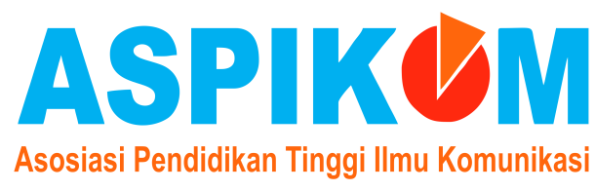

Subject : Copyright and Originality

COPYRIGHT AND ORIGINALITY

I declare that the article titled:

Aisyiyah Organizational Communication In Realizing The True Islamic Society (Case Study PCA Aisiyah Ngampilan Yogyakarta)
It is original, has not been published and will not be republished in other publications.

With this publication, I transfer copyright to the Committee of the Jurnal ASPIKOM.

The transfer of copyright includes the exclusive right to reproduce and distribute the article, including reprints. It also includes the right to adapt the articles used in conjunction with a computer system including reproduction or publication in the form online and mounted on a retrieval system.

Author's,
Yogyakarta, 10 Januari 2020
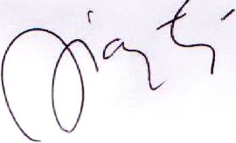

(Dr. Adhianty Nurjanah, S.Sos., M.Si)

